1) Create one Jenkins job using the below code and create three stages.

stage1: Git clone to download the source code.

🡪Add git clone URL in Jenkins at repository URL

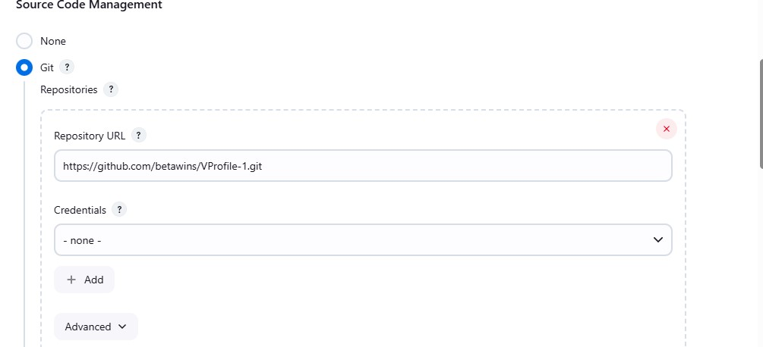

🡪go to Master instance check the repository is cloned or not??....

Check for directory that contains the git repository…

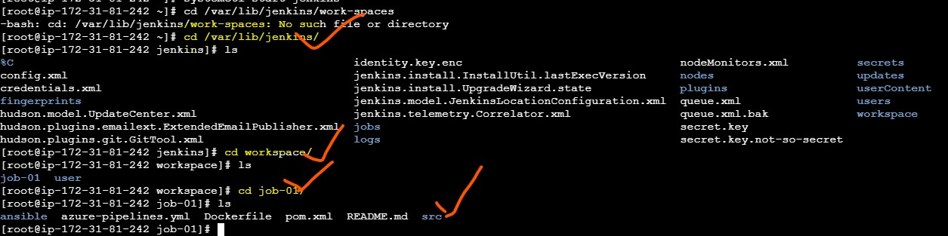

**stage2: Sonarqube Integration to check the quality of code**

Create another instance for sonarqube with t2.large as instance size

Volume should 20 🡪 create the instance

Log in to the server and install java

Update the package:- sudo yum update –y

Download the mysql server from this link:-

*sudo wget https://dev.mysql.com/get/mysql57-community-release-el7-11.noarch.rpm*

*sudo yum localinstall mysql57-community-release-el7-11.noarch.rpm*

*rpm --import https://repo.mysql.com/RPM-GPG-KEY-mysql-2022*

*sudo yum install mysql-community-server*

*sudo systemctl start mysqld.service*

Start MySQL and Enable Start at Boot Time

*systemctl start mysqld*

*systemctl enable mysqld*

Check if mysql is running or not:- *netstat -na | grep 3306*

Configure the MySQL Root Password

You will see default MySQL root password:- *grep 'temporary' /var/log/mysqld.log*

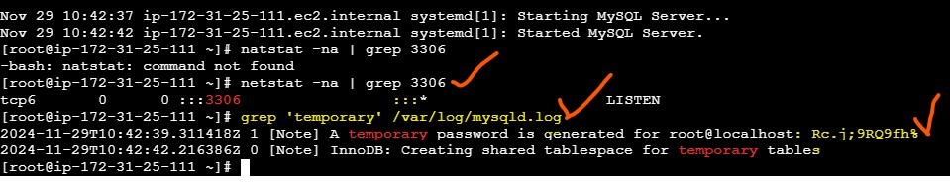

Login to mysql:- *mysql -u root –p*

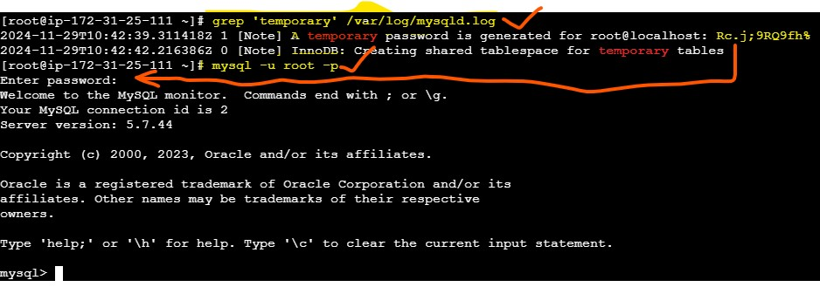

stage3: Slack Integration to send the alerts to slack.

URL: <https://github.com/betawins/VProfile-1.git>

yxQud0lphr-a

1) Create one Jenkins job using the below code and create three stages. stage1: Git clone to download the source code.

stage2: Sonarqube Integration to check the quality of code.

stage3: Slack Integration to send the alerts to slack. URL: <https://github.com/betawins/hiring-app.git>